CS311 Yoshii - HW2 Part 1– Algorithm Analysis (Based on Notes-3B and 4A)

DUE: Week 4 Sat

TOTAL: 22 points Your score is:

Your NAME: Victor Nguyen

Date Turned in: 9/21/2019

A) Review Questions [1 pt per question = 11pts] Your score is:
Type your answers here. Answer completely. Always say what kind of operations.
- Declare a 4x4 matrix containg a vector of integers. vector <int> M[4][4]
- What does W(n) mean in general? (W? n? W(n)?) W(n) means worst case scenario for the amount of comparisons an algorithm has to do for n amount of elements given to said algorithm. The max amount of comparsions it would have to do to obtain its result.
- For sequential search:
  - W(n) = O(n)
  - When does it happen? Worst case would happen for this algorithm is when the elements the algoirthm is looking for is at the very end of the list/array/vector.
- What does B(n) mean in general? (B?, n?, B(n)?) B(n) means best case scenario for the amount of comparisons an algorithm has to do for n amount of elements given to said algorithm. The least amount of comparsions it would have to do to obtain its result.
- For sequential search:
  - B(n) = O(1)
  - When does it happen? Best case would happen for this algorithm is when the element the algoritim is looking for is at the very front of the list/array/vector.
- Why is A(n) difficult to determine for the real world problems? A(n) is difficult to determine for a real world problem because it’s hard to probabilities for each type of input which the algorithm must take in account.
- Why don’t we care about constants and lesser terms in a time complexity expression? We don’t care about constants in a time complexity expression because the expression only describes the growth rate of algorithms rather than the actual run time of an algorithm on a machine.
- Prove that 3n^2 + 4n = O(n^2) as I did in the notes. (must give C and the starting point for n) 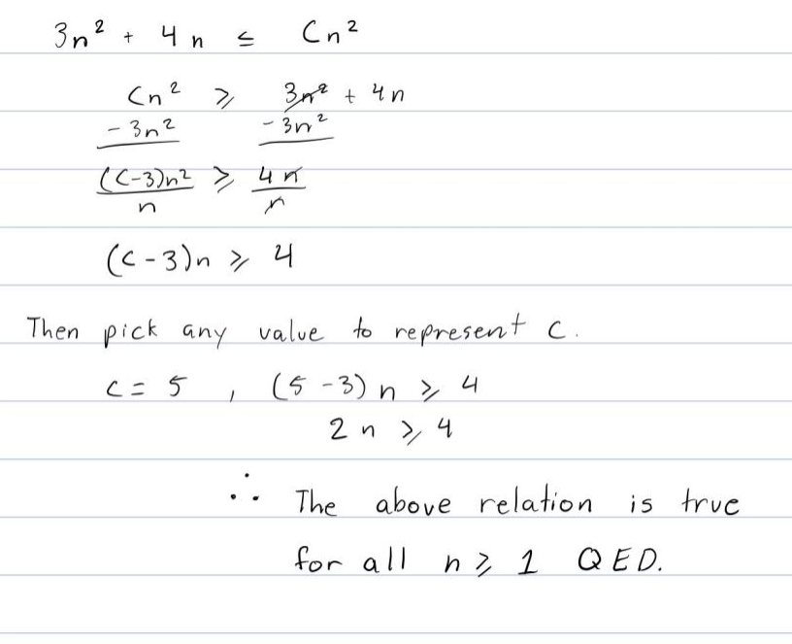
- Binary search corresponds to the _______Rika(triangle form)_______binary search tree.
Sequential search corresponds to a / the _____Kobe_______ tree.
Hint: think of the shape/height
- Thus, the fastest ordered list search does W(n)=Theta(logn) comparisons.
- But, the fastest unordered list search does W(n)=Theta(n) comparisons.

B) Program: Binary Search [2+9=11 pts] Your score is:
Code:
Comments:
Test results:
Total 9 points:
Q’s 2 points:
Q. State of your program [2pts]
- Does your program compile without errors? If not, describe. My program compiled with no errors and was able to produce results similar to the given results.
- List any bugs you are aware of, or state “No bugs”: My program has no bugs to my knowledge.

- No ADT; Just one source code file - Run my solution program first!!
- Using Notes-4A.doc, implement and test the recursive binary search function.
- Must use binsearch.cpp
- The pseudo code in the file does not take care of the cases where the element is not found. You must fix the code to take care of such cases and return -1.
- Also, display “comparing against the element in slot <slot>” each time you find the mid point.

Your main() will fill an array of 10 slots with integers 1 3 5 7 9 11 13 15 17 19
It will then ask the user to enter a number to look for.
It will then call binarySearch and display the returned result.
e.g. “The number was found in position 5” or “The number was not found”

Required Testing and expected results: (must test in this order!) ➔ Test.txt
- Find 1 in position 1 (It is not position 0!)
- Find 19 in position 10
- Find 5 in position 3
- Find 17 in position 9
- Find 21 fails
- Find 0 fails
- Find 6 fails
Make sure the number of comparisons is what you expected.

SUBMIT THESE 3 FILES:
- This assignment sheet with your answers.
- binsearch.cpp: The source code file for the program with good comments.
- Test.txt: Script of the compilation and test results on Empress.

